|  |  |
| --- | --- |
| Prefix | Example in text |
| Antivirus | I install an antivirus to protect my PC |
| Defrost | Please defrost the chicken before cooking |
| Disagree | I disagree with your opinion |
| Encourage | Teachers should encourage students to learn |
| Forecast | The weather forecast says it Will rain |
| Invisible | The magician seemed invisible on stage |
| Midday | We’ll meet again around midday |
| Misunderstand | I think your misunderstand my point |
| Nonstop | It’s a nonstop flight to Spain |
| Overreat | I tend to overrat when I’m stressed |
| Preuniversity | She wants to make a preuniversity |
| Rewrite | You need to rewrite your essay |
| Semifinal | The semifinal is in the night |
| Submarine | The submarine disappeared |
| Superpower | Flying is his main superpower |
| Transport | The truck is used to transport goods |
| Unhappy | She was unhappy |
| Underrated | That movie is underrated it´s actually great |

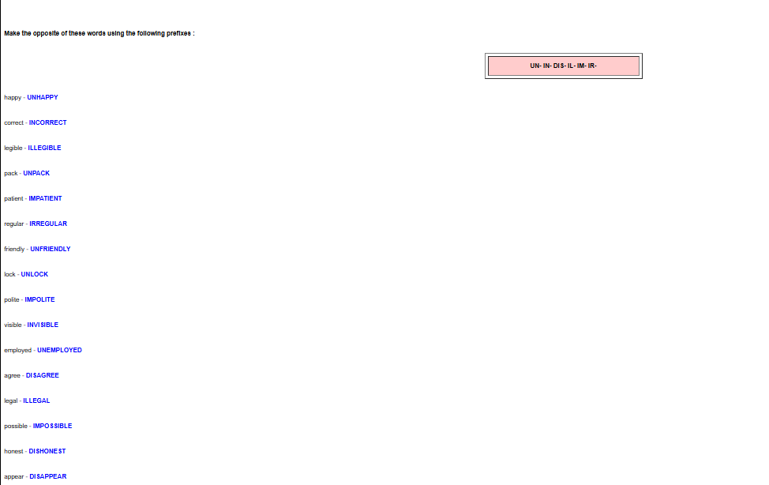

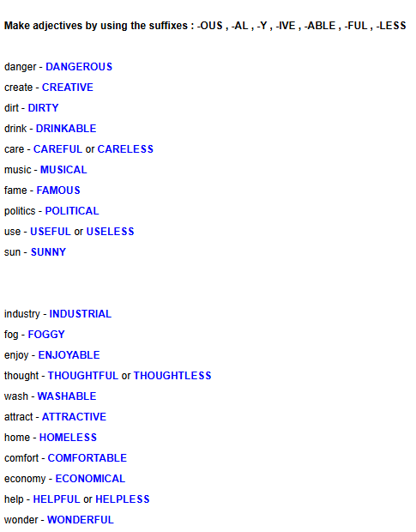

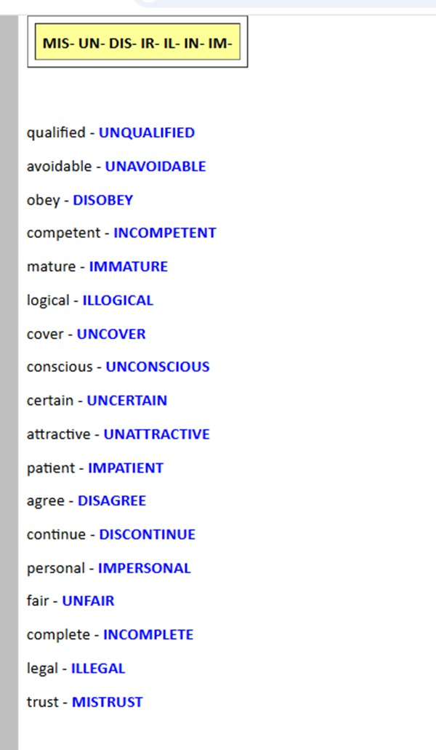

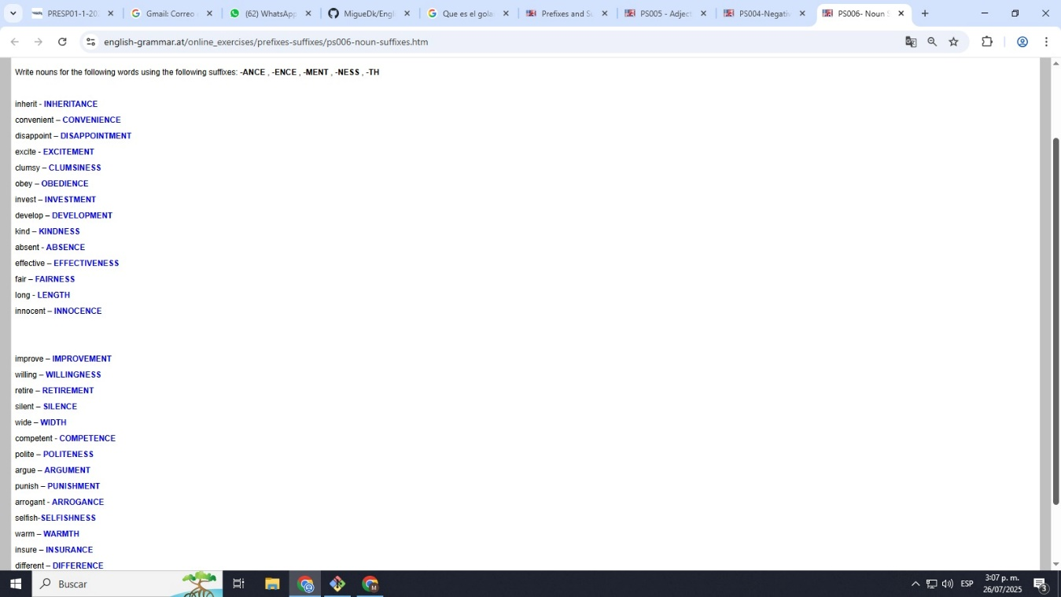

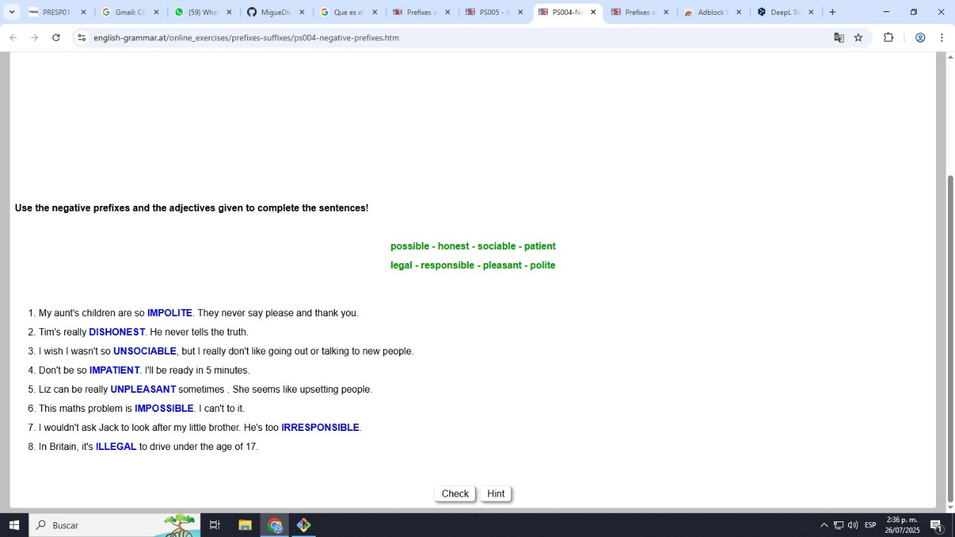

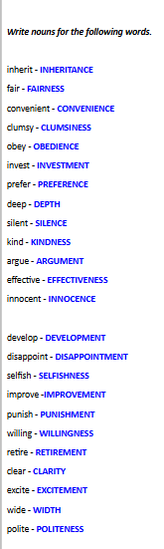

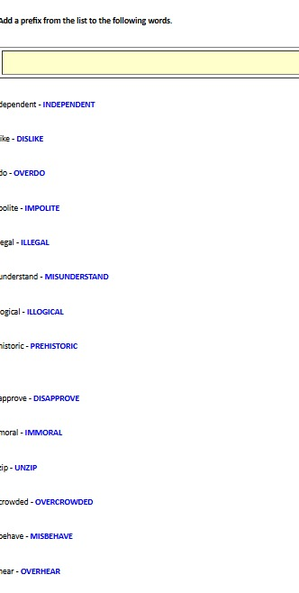

SEGUNDO SABADO

|  |  |
| --- | --- |
| suffix | Example in text |
| enjoyable | The movie was so **enjoyable** that I didn’t want it to end. |
| Personal | I have a **personal** goal to read 20 books this year. |
| Played | He **played** soccer for the first time in months and felt great. |
| Golden | They celebrated their **golden** anniversary with a huge party. |
| Bigger | This new house is **bigger** than the one we had before. |
| Engineer | My cousin is an **engineer**, and she designs cutting-edge technology. |
| Wonderful | The sunset over the beach was absolutely **wonderful** last night. |
| Informatic | She works in the **informatic** field, specializing in software development. |
| Sleeping | The baby is **sleeping** peacefully in her crib. |
| information | I need to gather more **information** before making a decision. |
| Activity | Hiking is a great **activity** for both exercise and relaxation. |
| Creative | The artist has a very **creative** approach to painting. |
| Careless | His **careless** mistake cost the team the game |
| establishment | The restaurant has become a well-known **establishment** in the city. |
| selfishness | His **selfishness** was evident when he refused to share the prize. |
| Invictus | The poem **Invictus** is about resilience and overcoming adversity. |
| students | The **students** were excited about their upcoming field trip. |
| lucky | I felt **lucky** to find such a great deal on the perfect pair of shoes. |

